**Project: MTA Subway data**

Team members: Brittani Kauf, Diane Ferrera, Jason Danforth

Project Link: <https://github.com/jason-danforth/Project1_DianeBrittaniJason>

Presentation Link: <https://docs.google.com/presentation/d/1fqYyOaLDJhWUYRmQgvo_AciWO9LtgGbihxXn3y_oqqE/edit?usp=sharing>

Notebook Descriptions:

* 190816_AnnualRidership.ipnb: code to produce content from presentation slides 6-23 (Ridership Overview, Subway Ridership Increase/Decrease per Line, Overall Ridership 2016-2018)
* 190817_MTA_API: code attempting to use NTA API to generate ordered list of subway stops per line
* Brittani notebook(s)
* Diane notebook(s)

**Questions**

How can we better understand the complexity of changes in subway ridership? Is ridership decreasing evenly across the entire system? Are certain lines or stations impacted more than others?

We were able to clearly demonstrate that the decrease in ridership is unevenly distributed across the subway system, with dramatic decreases on certain stations and notable increases on others.

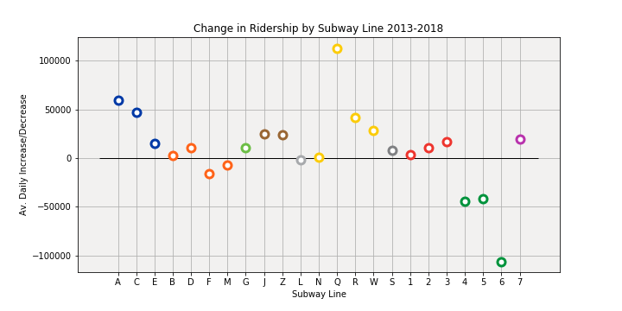

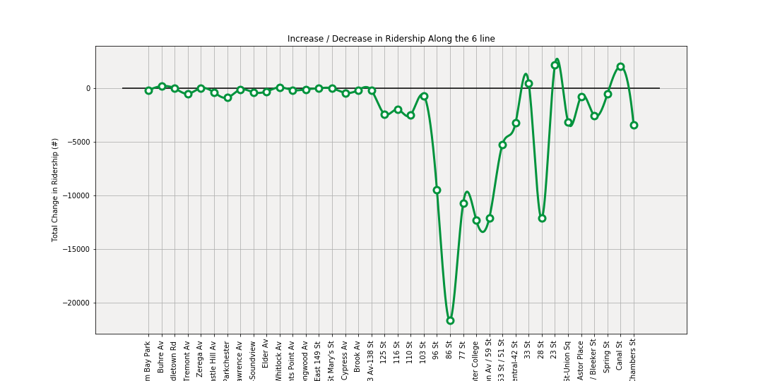

However, after further inspection it appears that the biggest increases and decreases are directly related to MTA maintenance or the opening of new stations/lines, so a thorough understanding of how ridership is being affected by routine maintenance of rideshare companies like Uber and Lyft would require a more detailed analysis of the myriad and distributed decreases in ridership occurring throughout the smaller stations, particularly in the outer boroughs.

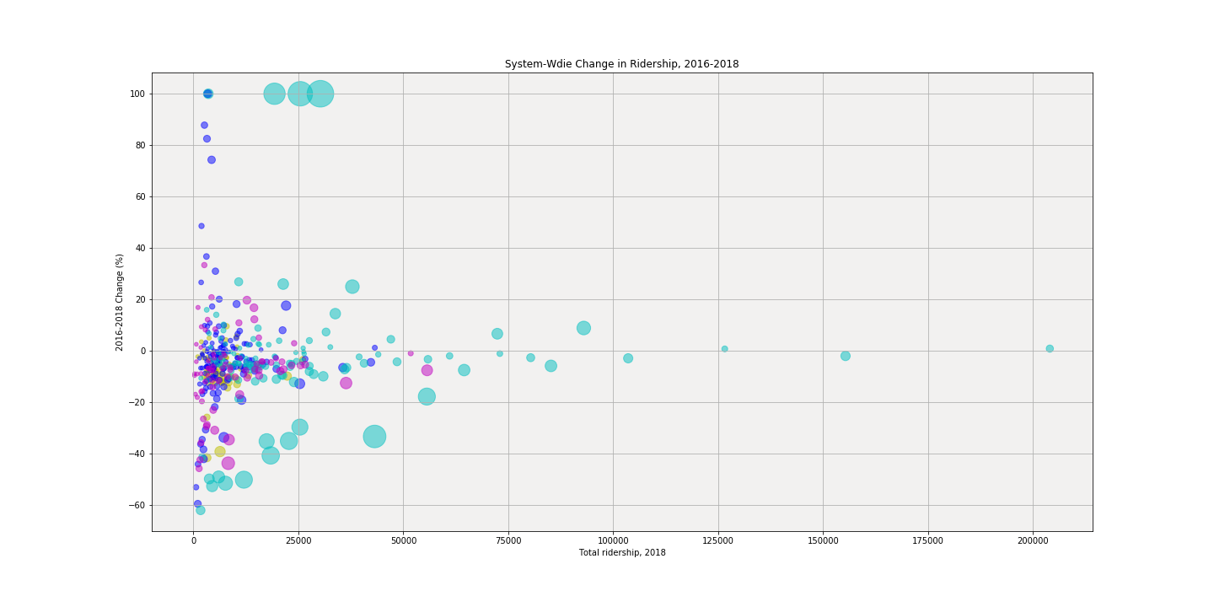

That said, it is worth noting that articles such as [the New York Times piece](https://www.nytimes.com/2018/08/01/nyregion/subway-ridership-nyc-metro.html) that inspired this project, should take care that any attempt to understand the overall health of the subway system account for outliers such as the new stations along the 2nd Avenue Subway or the opening of the Fulton Center and WTC stations.